**Introduction (Business Need):**

In the banking domain, identity personification could be used to impersonate customers and gain access to their accounts. This could lead to financial losses for customers and banks. Banks need to be able to protect their customers from identity theft and fraud. One way to do this is to develop solutions that can detect and prevent AI-generated voice impersonation.

**Challenge Description:**

The primary objective of this challenge is to develop effective countermeasures against identity personification using AI-generated voice prints. This challenge seeks to address the growing threat of voice-based fraud and protect individuals and organizations from unauthorized access and impersonation.

**Objective/Task 1:**

***AI-Based Voice Verification:*** *Develop AI algorithms capable of distinguishing between authentic and AI-generated voice prints.*

**Objective/Task 2:**

***Speech Pattern Analysis:*** *Analyze speech patterns, intonation, and other subtle vocal cues to identify anomalies indicative of AI-generated speech.*

**Objective/Task 3:**

***Liveness Detection:*** *Incorporate liveness detection techniques to ensure that voice samples are produced by a live person and not a recording or AI simulation.*

**Additional details on functionality:**

The evaluation of countermeasures against identity personification using AI-generated voice prints will be based on the following criteria:

*1.* ***Accuracy:*** *The ability to correctly identify AI-generated voice prints and distinguish them from authentic voice prints.*

*2.* ***Generalizability:*** *The system's ability to detect AI-generated voice prints across various voice domains, accents, and speaking styles.*

*3.* ***Robustness:*** *The system's resilience against adversarial techniques and its ability to adapt to evolving AI-generated voice prints*

**Prerequisites:-**

1. Generate synthetic data for training and testing purposes.

**References for generating the datasets:**

* <https://elevenlabs.io/>
* <https://audiobox.metademolab.com/>

## Solution Package:

Following are the tasks that need to be executed as part of this challenge:

* Provide high level user stories for the challenge.
* Provide a Design approach.
* Code that needs to be uploaded to the Git repo (Instructions for Git).
* Provide playbook.
* Automated test suite and coverage report.

Details of each of the deliverables are as follows:

#### User Stories

This document needs to capture the high level user stories that are part of the platform design. It would be desirable to have roles/actors to be part of the user stories and scenarios that were considered.

#### Design Approach

The design document should detail out overall approach on solving the problem. This could include any class diagrams/sequence diagrams indicating the approach and a high level traceability matrix.

#### Working code

The resultant application should have good quality and generic enough so that new rules can be added and/or removed easily and committed to respective Git repos that are assigned.

#### Playbook

Provide Playbook/Runbook for deploying the solution. Provide information towards how it should be deployed & monitored.

#### Automated Test Suite and Coverage Report

Test cases for various edge cases should be automated. Application needs to be tested as per the test cases and the results need to be captured along with the coverage report and any excel report and graphs.

#### Artifacts to be uploaded

Below mentioned artifacts and code to be uploaded to Git repository following the instructions below. It is mandatory to adhere to these instructions to be eligible for evaluation.

* Git repo has the following folder structure.
  + **Artifacts** 
    - **demo_presentation**
    - **design**
    - **playbook**
    - **test_results**
  + **Code**
* **Git folder structure**

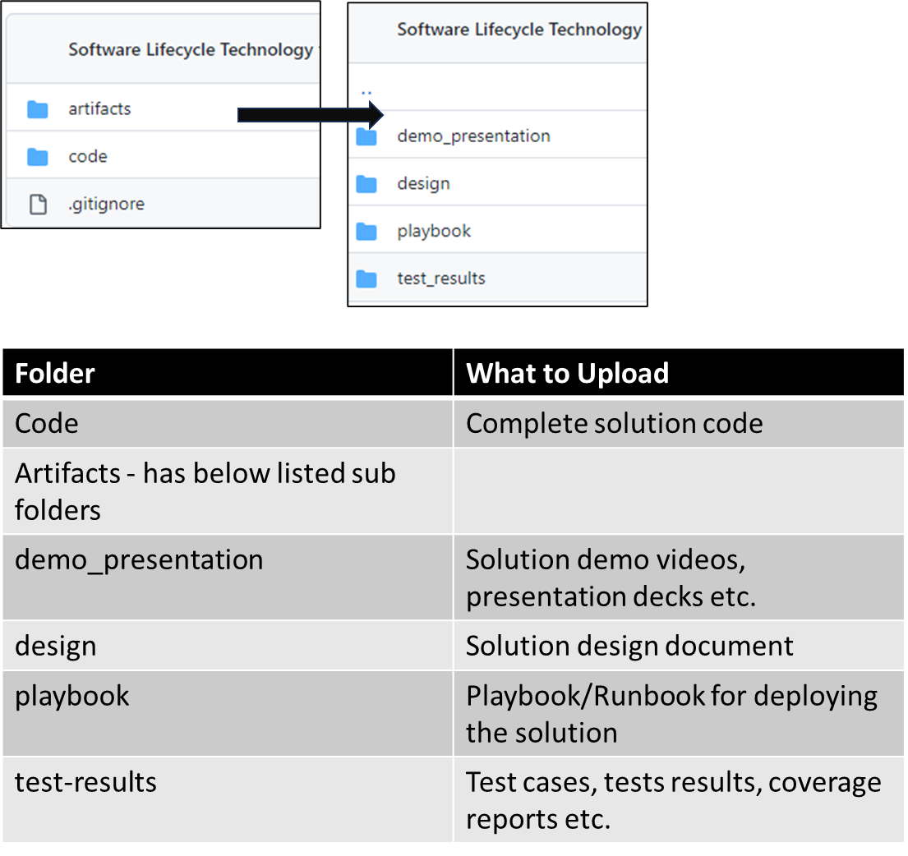

Git repo link for the dataset: <https://github.com/Hackathon2024-March/challenge-assets/tree/main/identity-personification>

## FAQs:

Please note: We recommend you refer to the common FAQs provided for the main challenge.

## Sample Request/Response:

**Analyze Voice Sample:**

**Endpoint: /voice/analyze**

The analysis now needs to autonomously detect the nature of the voice sample. The test cases will focus on the system's accuracy in distinguishing between human and synthetic voices.

**Test Case: Analyzing Human Voice Sample**

**Request:**

{

"sample": "audio.mp3"

}

**Expected Response:**

 {

"status": "success",

"analysis": {

"detectedVoice": true,

"voiceType": "human",

"confidenceScore": {

"aiProbability": 5,

"humanProbability": 95

} ,

"additionalInfo": {

"emotionalTone": "neutral",

"backgroundNoiseLevel": "low”

} },

”responseTime": 200}



#### Evaluation Criteria:

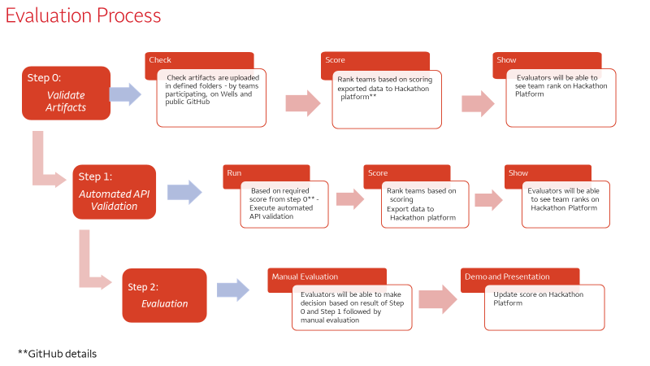

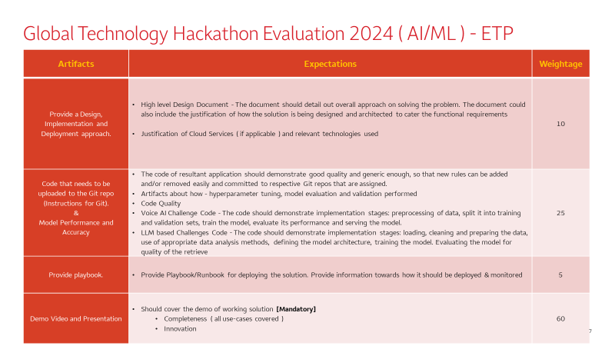f

